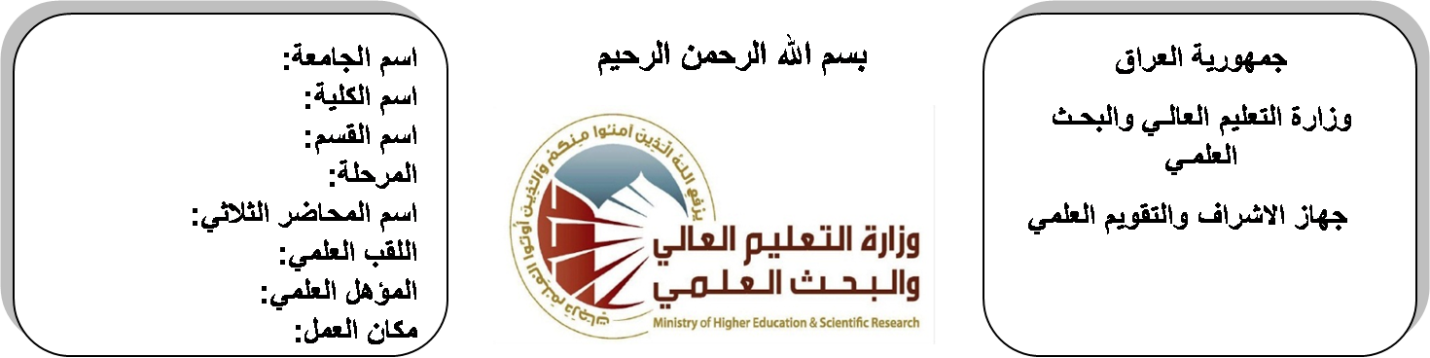

**Republic of Iraq**

**Ministry of Higher Education**

**& Scientific Research**

**University: Diyala University**

**College: College of Engineering**

**Department: Electronic Engineering**

**Stage: fourth**

**Lecturer name:** Hanan Badeea Ahmed

**Qualification: M.Sc**

**Place of work: Electronic Dept.**

**(( Annual teaching plan form))**

|  |  |  |  |  |
| --- | --- | --- | --- | --- |
| **Lecturer Name** | **Hanan Badeea Ahmed** | | | |
| **Email** | **Hanan1980@yahoo.com** | | | |
| **Subject** | Microwave | | | |
| **Aims** | **The aim of this subject is to make the students ready to undestand and comprehend the scientific theories and their applications related to their field of the study.** | | | |
| **Textbooks** | Microwave engineering by R.GOWRI | | | |
| **Additional Textbooks** | **Electromagnetics with applications by KRAUS/FLEISH** | | | |
| **Assessments** | **First Semester** | **Second Semester** | **Laboratory** | **Final Exam** |
| 20% | 20% |  | 60% |
| **Notes** |  | | | |

**Schedule Weekly Lessons - First Semester**

|  |  |  |  |  |
| --- | --- | --- | --- | --- |
| **Week** | **Date** | **Lectures** | **Lab. Experments** | **Notes** |
| 1 | **21/2/** | Electromagnetic Theory: Review |  |  |
| 2 | **28/2/** | Electromagnetic Theory: Review |  |  |
| 3 | **6/3/** | Transmission Lines in Microwaves |  |  |
| 4 | **13/3/** | Transmission Lines in Microwaves |  |  |
| 5 | **20/3/** | Microwave Network Analysis Using S-Parameters |  |  |
| 6 | **27/3/** | Microwave Network Analysis Using S-Parameters |  |  |
| 7 | **3/4/** | Passive Components in Microwave |  |  |
| 8 | **10/4/** | Passive Components in Microwave |  |  |
| 9 | **17/4/** | Microwave Filters |  |  |
| 10 | **24/4/** | Microwave Filters |  |  |
| 11 | **1/5/** | Design & Analysis of Ferromagnetic Components in Microwave. |  |  |
| 12 | **8/5/** | Design & Analysis of Ferromagnetic Components in Microwave. |  |  |
| 13 | **15/5/** | Active Microwave Circuits |  |  |
| 14 | **22/5/** | Active Microwave Circuits |  |  |
| 15 | **29/5/** | Microwave Tubes |  |  |
| 16 | **2/6/** | Microwave Tubes |  |  |
| Half Year holiday | 15/1/ to  1/2/ |  |  |  |

**Lecturer Signature Head of Dept. Signature Dean Signature**

**Schedule Weekly Lessons - Second Semester**

|  |  |  |  |  |
| --- | --- | --- | --- | --- |
| **Week** | **Date** | **Lectures** | **Lab. Experments** | **Notes** |
| 1 | **21/2/** | Diode & Transistors in Microwaves |  |  |
| 2 | **28/2/** | Diode & Transistors in Microwaves |  |  |
| 3 | **6/3/** | Microwave Amplifier Design |  |  |
| 4 | **13/3/** | Microwave Amplifier Design |  |  |
| 5 | **20/3/** | Microwave Oscillator Design |  |  |
| 6 | **27/3/** | Microwave Oscillator Design |  |  |
| 7 | **3/4/** | Microwave Integrated Circuits |  |  |
| 8 | **10/4/** | Microwave Integrated Circuits |  |  |
| 9 | **17/4/** | Microwave Integrated Circuits |  |  |
| 10 | **24/4/** | Applcation of Microwave in Communication Systems |  |  |
| 11 | **1/5/** | Applcation of Microwave in Communication Systems |  |  |
| 12 | **8/5/** | Applcation of Microwave in Communication Systems |  |  |
| 13 | **15/5/** | Applcation of Microwave in Communication Systems |  |  |
| 14 | **22/5/** | Radar System |  |  |
| 15 | **29/5/** | Radar System |  |  |
| 16 | **2/6/** | Radar System |  |  |

**Lecturer Signature Head of Dept. Signature Dean Signature**